**DBMS ASSIGNMENT 7**

**CLASS: TE B**

**ROLL NO: 322008**

**Problem Statement:** PL/SQL Stored Procedure and Stored Function.

Write a Stored Procedure namely proc_Grade for the categorization of student. If marks scored by students in examination is <=1500 and marks>=990 then student will be placed in distinction category if marks scored are between 989 and900 category is first class, if marks 899 and 825 category is Higher Second Class

Write a PL/SQL block for using procedure created with above requirement. Stud_Marks(name, total_marks) Result(Roll,Name, Class)

**Screenshots:**

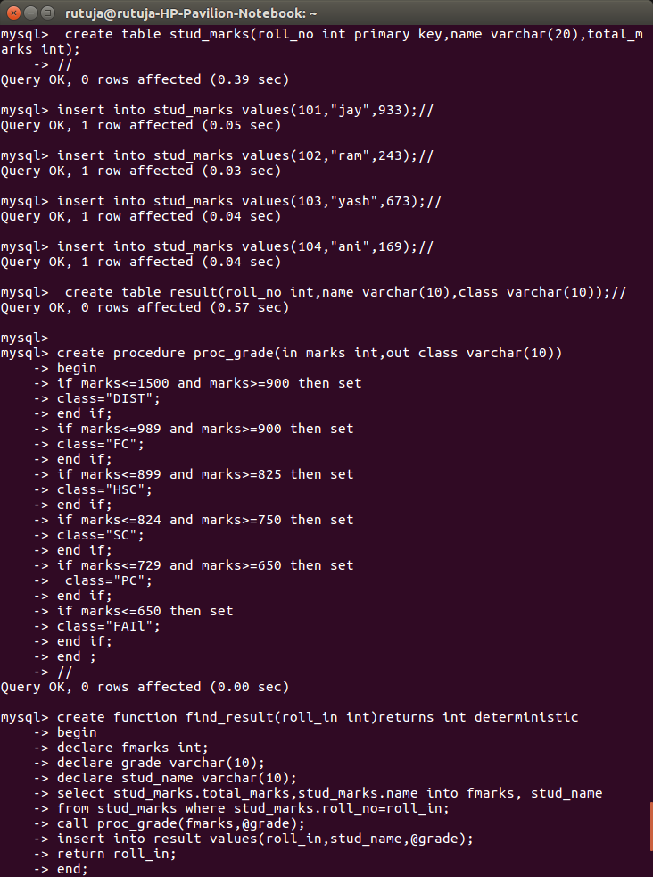

**Queries:**

Create procedure proc_grade(in marks int, out class varchar(10))

Begin

If marks <= 1500 and marks >=900 then set

Class = “DIST”;

End if;

If marks <= 989 and marks >=900 then set

Class = “FC”;

End if;

If marks <= 899 and marks >=825 then set

Class = “HSC”;

End if;

If marks <= 824 and marks >=750 then set

Class = “SC”;

End if;

If marks <= 729 and marks >=650 then set

Class = “PC”;

End if;

If marks <= 650 then set

Class = “FAIl”;

End if;

End;

//

Create function find_result(roll_in int) returns int deterministic

Begin

Declasre fmarks int;

Declare grade varchar(255);

Declare stud_name varchar(255);

Select stud_marks.total_marks, stud_marks.name into fmarks, stud_name

From stud_marks where stud_marks.roll_no = roll_in;

Call proc_grade(fmarks, @grade);

Insert into result values(roll_in, stud_name, @grade);

Return roll_in;

End;

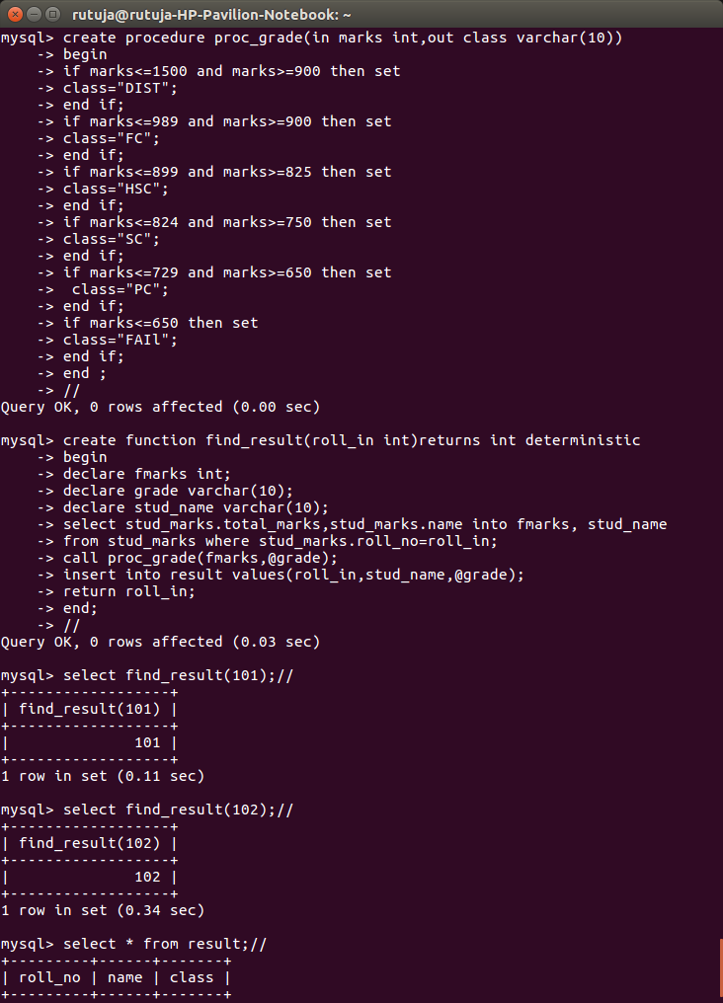

**Queries:**

Select find_result(101);

Select find_result(102);

Select * from result;

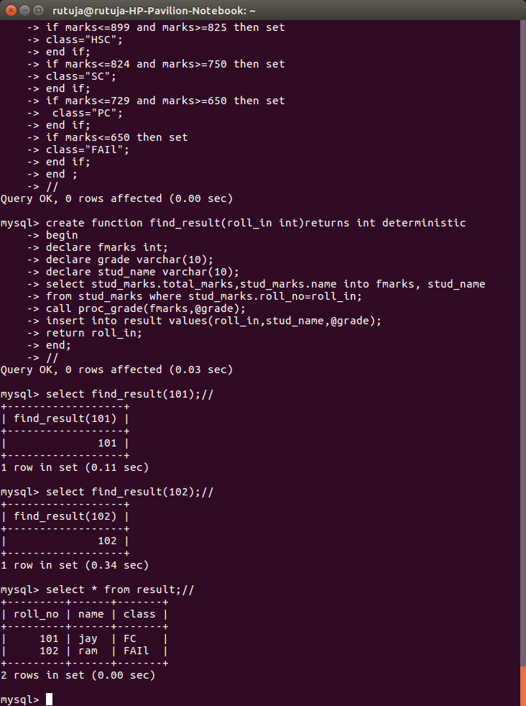

**Queries:**

Select * from result;

**Conclusion:** Pl/sql block was implemented successfully.